FISH 558: Decision Analysis in Natural Resource Management (Fall 2015)
HOMEWORK ASSIGNMENT-1 (due: 9 October 2015)
(Assessment of fin whales)
Fin whales (Balaenoptera physalus) in the North Atlantic have been harvested commercially and for aboriginal subsistence purposes since the 1920s. Several management stocks have been designated for fin whales in the North Atlantic based on genetic and non-genetic methods. One of these is the stock of fin whales off West Greenland. This is the only stock currently subject to harvest. The Scientific Committee of the International Whaling Commission aims to provide management advice for this stock annually. However, it has generally been “unable to provide satisfactory management advice” to date. This homework assignment explores the data for fin whales and why it has proven very difficult to provide management advice for this stock.
The population dynamics model to be fitted to the data for North Atlantic fin whales is:
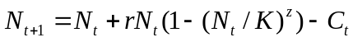 (1)
where 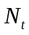 is the number of animals at the start of year t,
r is the intrinsic rate of growth,
z is the Pella-Tomlinson shape parameter (assumed to be 2.39 for these analyses so that 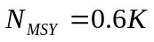),
 is the pre-exploitation population size (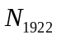 is assumed to be equal to K), and
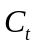 is the catch during year t (Table 1).
The likelihood function maximized to estimate the parameters of the model is:
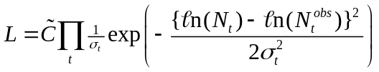 (2)
where 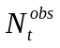 is the estimate of abundance for year t (see Table 2),
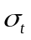 is the observation error standard deviation, calculated as:
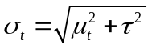
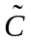 is a constant,
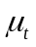 is the coefficient of variation associated with , and
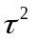 is the additional variance.

Tasks
- Show that MSYR (the ratio of MSY to 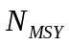) is approximately 0.705 r.
- Fit model (1) to the data for fin whales and find the “best estimates” for r, K and . Plot the time-trajectory of population size along with the data used to fit the model. Conduct the analysis using R (not ADMB even if you know how to code in ADMB).
- Based on the approximation 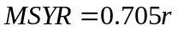, construct a likelihood profile for MSYR. What does this profile tell us regarding the information content of the data for fin whales?

Table 1. Catches of fin whales off West Greenland (1922-2004).

Year | Catch | Year | Catch | Year | Catch
1922 | 14 | 1952 | 16 | 1982 | 9
1923 | 20 | 1953 | 16 | 1983 | 8
1924 | 94 | 1954 | 22 | 1984 | 10
1925 | 30 | 1955 | 22 | 1985 | 9
1926 | 24 | 1956 | 28 | 1986 | 9
1927 | 22 | 1957 | 21 | 1987 | 9
1928 | 24 | 1958 | 8 | 1988 | 9
1929 | 24 | 1959 | 1 | 1989 | 14
1930 | 27 | 1960 | 0 | 1990 | 19
1931 | 301 | 1961 | 0 | 1991 | 18
1932 | 66 | 1962 | 0 | 1992 | 22
1933 | 24 | 1963 | 0 | 1993 | 14
1934 | 24 | 1964 | 1 | 1994 | 22
1935 | 23 | 1965 | 1 | 1995 | 12
1936 | 15 | 1966 | 0 | 1996 | 19
1937 | 272 | 1967 | 0 | 1997 | 13
1938 | 7 | 1968 | 3 | 1998 | 11
1939 | 3 | 1969 | 0 | 1999 | 9
1940 | 0 | 1970 | 0 | 2000 | 7
1941 | 0 | 1971 | 0 | 2001 | 8
1942 | 0 | 1972 | 1 | 2002 | 13
1943 | 0 | 1973 | 2 | 2003 | 9
1944 | 0 | 1974 | 5 | 2004 | 13
1945 | 0 | 1975 | 2
1946 | 47 | 1976 | 9
1947 | 51 | 1977 | 13
1948 | 21 | 1978 | 8
1949 | 21 | 1979 | 7
1950 | 36 | 1980 | 13
1951 | 15 | 1981 | 7

Table 2. The estimates of abundance for West Greenland fin whales

Year | Estimate | CV ()
1988 | 1096 | 0.35
1993 | 178 | 0.50
2003 | 980 | 0.48

